# Selfie:

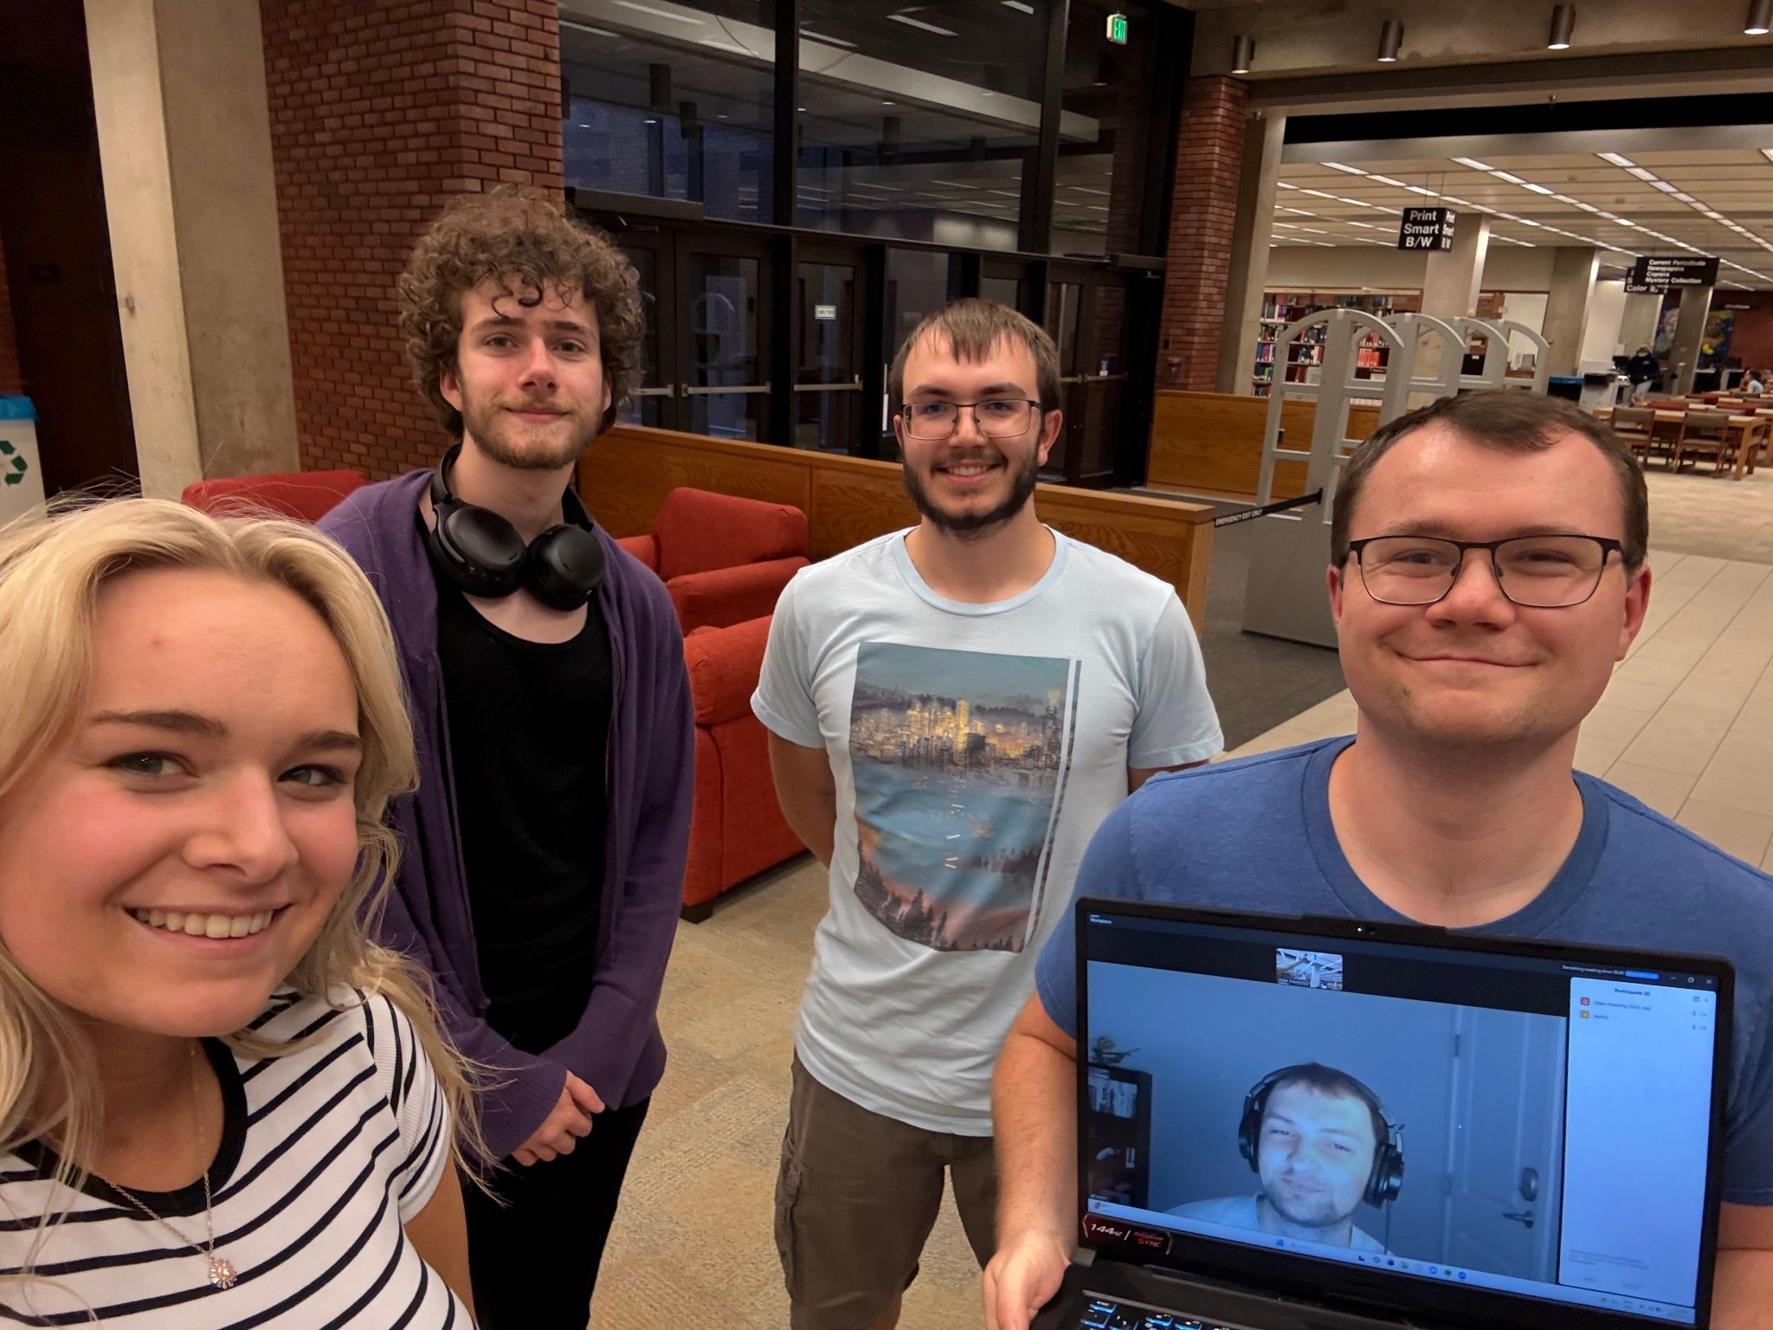

# Part 1: Avatar

* Water
  + Pros
    - Extra power in certain times of the moon cycle
    - Defensibility; walls of water, flushing things away, making ice, etc
    - Blood bending; being able to control peoples movements
    - Agriculture and healing
    - Movement capabilities
  + Cons
    - You need access to water
    - Tied to emotional state; can have high variance
    - Highly telegraphed moves
* Fire
  + Pros
    - Industry; steel production
    - Always have the ability to start a fire/produce heat
    - Highest damage potential
  + Cons
    - Unpredictable results and can be hard to control
    - Weakened at the poles; power is tied to the sun
    - Easily countered by other elements
* Earth
  + Pros
    - Easy travel with groundsurfing
    - Can manipulate basically everything solid around you, including metal and sand
    - Very suitable for protection and combat (foot traps, walls, etc)
  + Cons
    - Need some material to control
    - Takes immense practice for more niche uses (sand, metal, etc)
    - High environmental damage
* Air
  + Pros
    - Almost always have it
    - Instakill by sucking air out of their lungs
    - Best mobility
  + Cons
    - Highest emotional needs (can’t fly anymore)
    - Lowest immediate damage potential
    - Restricted in buildings and other tight spaces
* Favorites
  + Gabe
    - Airbending, because the movement capabilities are very enticing. It also has the quickest way of dispatching enemies if the time ever comes where I need to defend myself or the people around me. It also is almost never useless, and I don’t think the downsides would come up with me personally too often.
  + Dustin
    - Earthbending, because I think it would be cool to be able to manipulate and shape the ground beneath you. You would be able to make any landscape you want.
  + Jaydon
    - Earthbending, because I like being able to bend the ground, and then also being able to bend magma from the earth and steel is pretty sick. Air is a close second for me too.
  + Alli
    - Firebending is pretty neat because you can’t predict how your own powers will behave and what they are capable of. You can easily underestimate this element at times.
  + Noah
    - Air because of that one monk who was a pacifist but had 10+ dead bodies around him.

# Part 2: Team Policy

### Meeting Guidelines:

* Frequency and Duration
  + At least twice a week
  + One longer meeting, 20-30 minutes (more or less as needed)
  + One shorter meeting for check-in, 5-10 minutes (more or less as needed)
* Format
  + Virtually, over Zoom
* Agenda
  + Set weekly by group consensus
  + Shared over Slack
* Minutes
  + Gabe will take meeting notes and put them on a Google Doc
  + <https://docs.google.com/document/d/1MoWkakwddNe-64NwCWkKjt594yVfpl9iJde7CGzfhTc/edit?tab=t.0>
* Accountability
  + Everyone is expected to be at every meeting barring extreme circumstances
    - Illness and emergencies
  + Everyone talk about what they are currently doing, what future plans are, dependencies, and asking for help if you need it

### Roles and Responsibilities:

* Team Leader
  + Alli
    - Especially when it comes to client communication
* Task Division and Tracking
  + Agile
    - Gives more flexibility
* Roles
  + Start out flexible, figure out where people work best and then slot them in there
  + Stay relatively fixed

### Strengths and Weaknesses:

* Gabe
  + Strengths
    - Project Management
    - Communication
    - Organization, detail-minded and consistency
    - Decent backend ability
  + Weaknesses
    - Front end
    - Not great at lengthy sessions; better in spurts
  + Expectations
    - I look forward to the experience with this project (teamwork, client communication, documentation, etc) and want to put forth a good product, but my lesser-focused major is Computer Science so this isn’t my academic focus.
  + Effort Level
    - Enough effort to fulfill my tasks so the project is where it needs to be
* Dustin
  + Strengths
    - Mildly good with front-end and back-end code
    - Good communicator within a team
  + Weaknesses
    - Cloud deployment
    - Not a lot of exposure to frameworks
    - Mobile development
  + Expectations
    - I want to put in a lot of work to the point that the outcome of this project is impressive and well-made.
  + Effort Level
    - I will give the effort needed to complete my parts of the project and help others if I can.
* Jaydon
  + Strengths
    - Writing larger blocks of code in longer sessions/trial and error
    - Front end
  + Weaknesses
    - Organization of code
    - Back end
  + Expectations
    - I want to have an actual real life experience with developing something for a client
  + Effort Level
    - I am able to give whatever amount of effort we need depending on the situation
* Alli
  + Strengths
    - Visually oriented (lots of drawing, graphics)
    - Front end
    - Management
    - Documentation
    - Organized
    - People/Computer interactions
  + Weaknesses
    - I can have a short train of thought and can jump from one idea to another
  + Expectations
    - I am employed by a company for software dev in Ft Wayne and strive to impress them with this project
  + Effort Level
    - I plan to give this project all I got to impress our clients and my employer, I want to give around 4 hours per week as necessary.
* Noah
  + Strengths
    - Back end
    - Bug fixing
    - Documentation
    - Databases
  + Weaknesses
    - Management
    - Front end
  + Expectations
    - I mostly want to learn new things and figure out how to build larger projects.
  + Effort Level
    - Depends on how much we need. I will respond in a manner fitting, but I’m good to contribute at least 3hrs a week outside class.

### Conflict Resolution:

* Escalation Path
  + Team discussion
  + Dr. Ergin
* Decision-Making Process
  + Intuition
  + Voting

### Works Hours and Availability:

* Availability
  + Gabe (In-person or Zoom) 574-806-6265
    - Mon: 9-10:30am, 4-6pm, could potentially go until 7:30 some days
    - Tues: 9-10:30am, 2-6pm, could potentially go until 7:30 some days
    - Wed: 9-10:30am, 4-6pm, could potentially go until 7:30 some days
    - Thurs: 9-10:30am, 2-6pm, could potentially go until 7:30 some days
    - Fri: 9-10:30am, 4-6pm, could potentially go until 7:30 some days
    - Sat: Usually free all day from 10am-8pm
    - Sun: 10am-12:30pm
  + Dustin (Preferred Zoom) @ 765-993-8738
    - Mon: 10am - 12pm & 5pm - 10pm
    - Tues: 12:30pm - 10pm
    - Wed: 10am - 12pm & 5pm - 10pm
    - Thurs: 12:30pm - 10pm
    - Fri: 10am - 12pm & 5pm - 10pm
    - Sat: 4pm - 10pm via Zoom
    - Sun: 4pm - 10pm via Zoom
  + Jaydon (765-603-6949)
    - Mon: 2-4pm, 6-8pm
    - Tues: 9-11am, 12:15-2pm
    - Wed: 2-4pm, 6-8pm
    - Thurs: 9-11am, 6-8pm
    - Fri: 2-4pm, 6-8pm
    - Sat: all day
    - Sun: all day
  + Alli (Preferred Zoom, live off-campus and work remote) @ 260-445-3508
    - Mon: 12pm-12:30pm via Zoom, 3pm - 10pm
    - Tues: 7:30am-9:30am, 12:30pm-1pm via Zoom, 4pm - 10pm
    - Wed: 11am - 11:30 am via Zoom, 3 pm - 10 pm
    - Thurs: 7:30am-9:30am, 12:30pm-1pm via Zoom, 4pm - 10pm
    - Fri: 12pm-12:30pm via Zoom, 5pm - 10pm via Zoom
    - Sat: 4pm - 10pm via Zoom(Ft. Wayne)
    - Sun: Not preferred, only if necessary 5 pm - 8 pm via Zoom
  + Noah @ 574-835-5920
    - Mon: 12-1p, 2-6:30p, 8p ->
    - Tues: 12:15p ->
    - Wed: 12-1p, 2-6:30p, 8p ->
    - Thurs: 12:15p ->
    - Fri: 12-1p, 2p ->
    - Sat: Mostly free :)
    - Sun: Mostly free :)
* Workload
  + Gabe
    - I will make time for this as needed.
    - I am quite busy with other classes, work, varsity esports, and other extracurriculars but this project is important and will be a priority.
  + Dustin
    - Flexible: get what I need to get done on time
    - Try to prioritize this project over other classes
  + Jaydon
    - I can be flexible if need be, I have 4 other classes but the work load in those classes are usually light.
  + Alli
    - I will do what I commit myself to doing and if I struggle with that I will ask my team for help
  + Noah
    - I will do what is needed. Get it done.🤖

### Communication:

* Tools
  + Slack for general communication
  + Texting for urgent communication
* Expectations
  + Within 24hr for Slack
    - Don’t expect responses after 10pm or before 10am
  + ASAP for texting

### Struggle Timebox:

* Timebox
  + Feature
    - 3 hour of no progress
  + Bug
    - 1 hour of no progress
* Reason
  + We think that this is a reasonable amount of time for each
  + After hitting this point, you need a break; ask for help and chill
* Escalation Path
  + Teammates working on similar things
  + Other teammates
  + Dr. Ergin
  + Partner

### 